Geometry: Unit 8, Lesson 3

- What is a statement that is true about squares pertaining to sides?

All sides are congruent

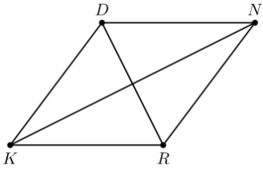
- Quadrilateral $KDNR$, a rhombus, is shown. Is the statement $\overline{RK}≅\overline{ND}$ true?

Yes

- What does a rectangle and square have in common?

A quadrilateral that contains four right angles and two pairs of parallel sides

